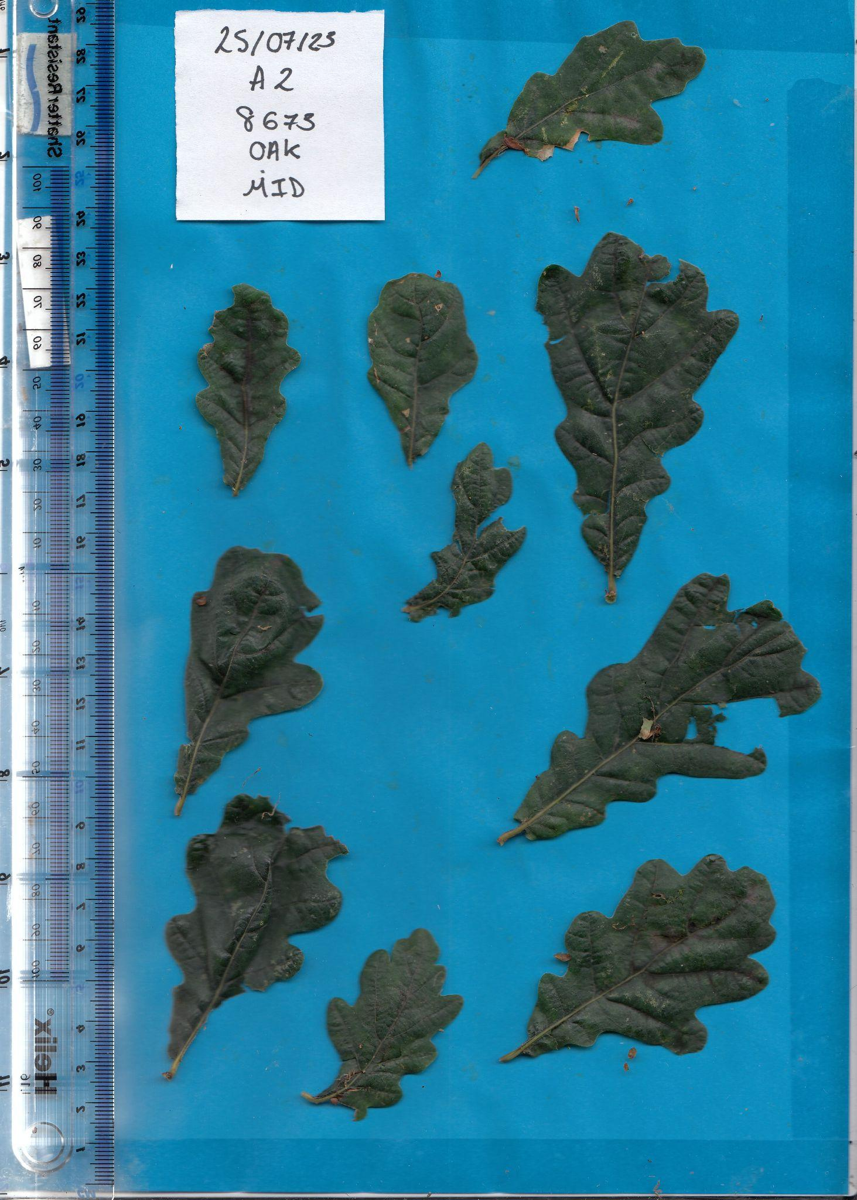

Example Image: Not Infected Oak Leaf with Powdery Mildew- PM % Score: 3.886856

